# CS 255 System Design Document Template

This template lays out all the different sections that you need to complete for Project Two. Each section has guidance to prompt your thinking. You will need to continually reference the interview transcript as you work to make sure that you are addressing your client’s needs. There is no required length for the final document. Instead the goal is to complete each section based on what your client’s needs are. Remove this note when you are finished, and replace all bracketed text with the relevant information.

## UML Diagrams

### UML Use Case Diagram

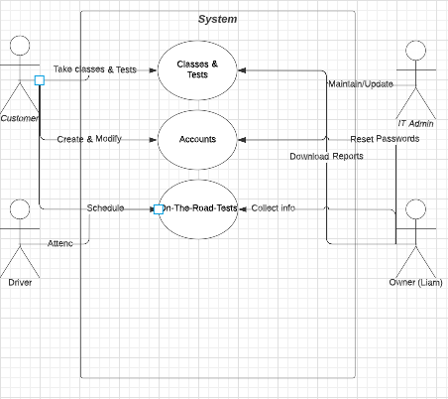

### UML Activity Diagrams

**Classes & Tests Use Case**

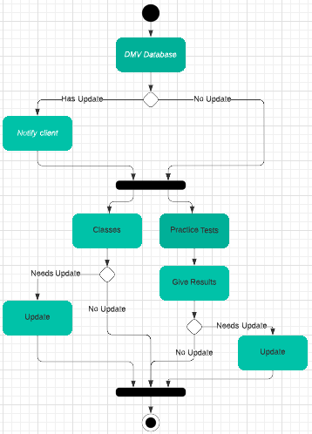

**Accounts Use Case**

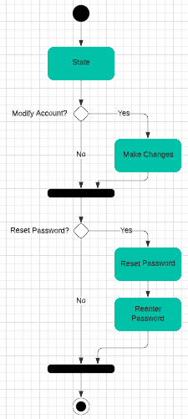

### UML Sequence Diagram

**On-The-Road-Test Use Case**

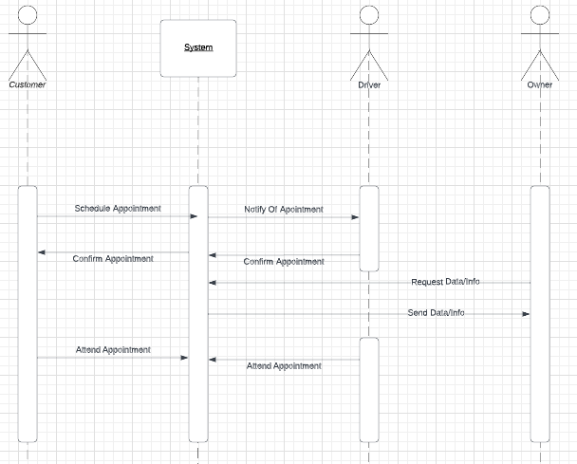

### UML Class Diagram

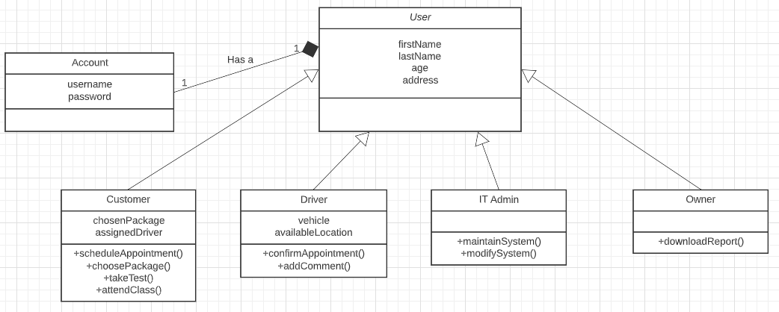

## Technical Requirements

The system should be easily accessible, and should be able to be used on mobile devices, so that the drivers can easily check their schedules while in their vehicles, and so that the owner can quickly find the info he needs.

The system should have proper authentication and authorization, so that the owner and IT Admin has more access than customers and drivers.

The system should be able to detect obvious human error, and notify the user of it. For example, this will prevent a customer from scheduling an appointment in 2922 instead of 2022.

The system should have proper security and encryption techniques put in place to ensure that user’s credentials and private information is secure within the chosen database.

The system should have a cloud-based database, as well as run entirely on the cloud.

The system should have proper maintainability measures put in place that allow the IT Admins to fix technical problems within a set timeframe.

The system should protect the customer’s sensitive data, for the benefit of their privacy. This is largely because both customers and drivers will likely attempt to access the system in public, such as the customer confirming the appointment time while waiting for the driver.

The system should have proper productivity measures put in place, to allow all users to be more productive. For example, it could automatically recommend which classes customers should take based on their scores on the practice tests.

The system should have proper serviceability measures put in place, so that the system is still usable while being updated. This is because it will be updated every time the DMV makes an alteration to their rules, which could be frequent.

The system should have proper system error backup plans for if an error occurs. For example, if the system crashes, it should notify each user of this, and encourage customers to confirm their already-scheduled appointments with their drivers via email.